Drive-train feasibility preface & discussion
If using the given motor data and treating it is accurate
Math for 3 or even 4 speeds make no sense.
4000 RPM to 7500RPM is 48kW
Powerband wide enough for a 2 speed or direct drive.
No real reason to have a super aggressive 1st gear as 120Nm torque instant from 0 RPM which means if we multiply the torque too much, we would exceed the grip of the tires or do a wheelie and flip the bike
Past 2nd speed doesn’t make sense since the limit wouldn’t be the motor it would be the physics of the rubber and bike’s CoG

Mechanical losses:
Direct Drive: 95-97% efficient (assumed at 96% for sim-sake)
2-Speed gearbox: 93-94% efficient (internal gear mesh + shaft bearings, assumed at 93% for sim-sake)
3-speed gearbox: heavier, wider casing which tanks efficiency and reduces potential battery size (Efficiency assumed as same as 2-speed eventhough that isn’t possible)
Only reason for a 3-speed gearbox is if the motor were to overheat too much otherwise the energy saved electrically is very nearly the same as the energy lost by mechanical friction of a complex gearbox. (No direct comment on our exact bike about this though)

Since regen braking is used, direct drive is the simplest seamless predictable solution, a 2 speed gearbox requires a more complicated logic to maximise energy gained (braking hard in 2 speed reduces back-emf as rpm drops, downshifting can risk locking rear wheel and destabilising)

Another massive issue with a gearbox is the 50-150ms shift time (depending on the mechanism). During this the tractive force drops to zero, the aero drag is so high at high speed that even a 50ms shift will cause the bike to decelerate.
Regen braking not modeled
Summary: Bike can be designed to reach high speeds & laptime with a 2 speed gearbox, building more adds unnecessary weight, complexity, reduces reliability.
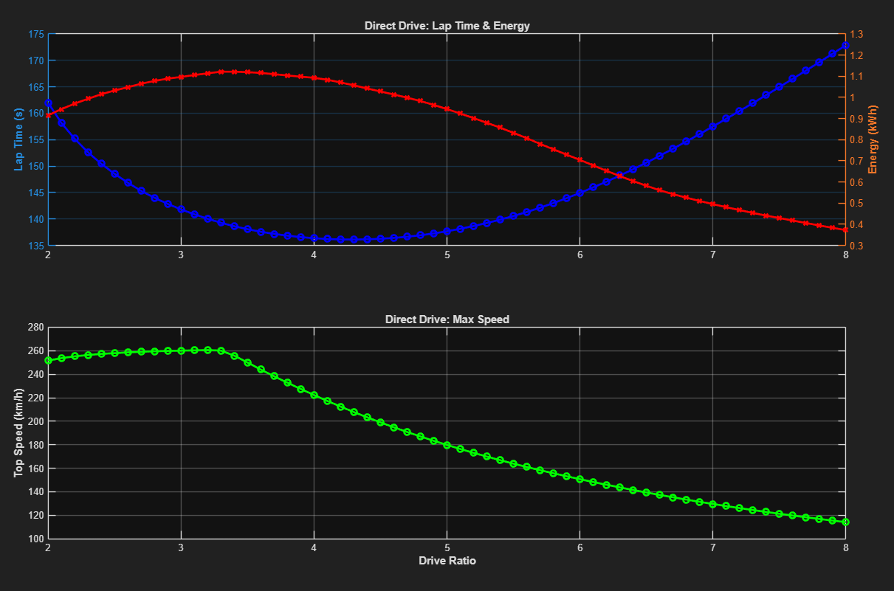
Direct Drive run
Lap time: 140.032 s
Average vehicle speed: 36.26 m/s (130.55 km/h)
Top Speed achieved: 260.52 km/h
Ratio: 3.2 | Lap: 140.03s | Energy: 1.11 kWh | Top Speed: 260.5 km/h
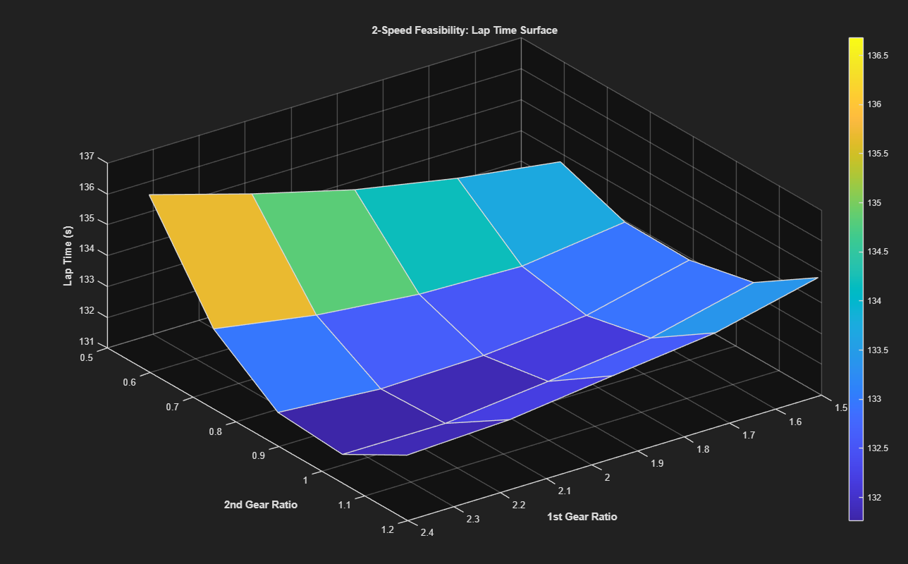
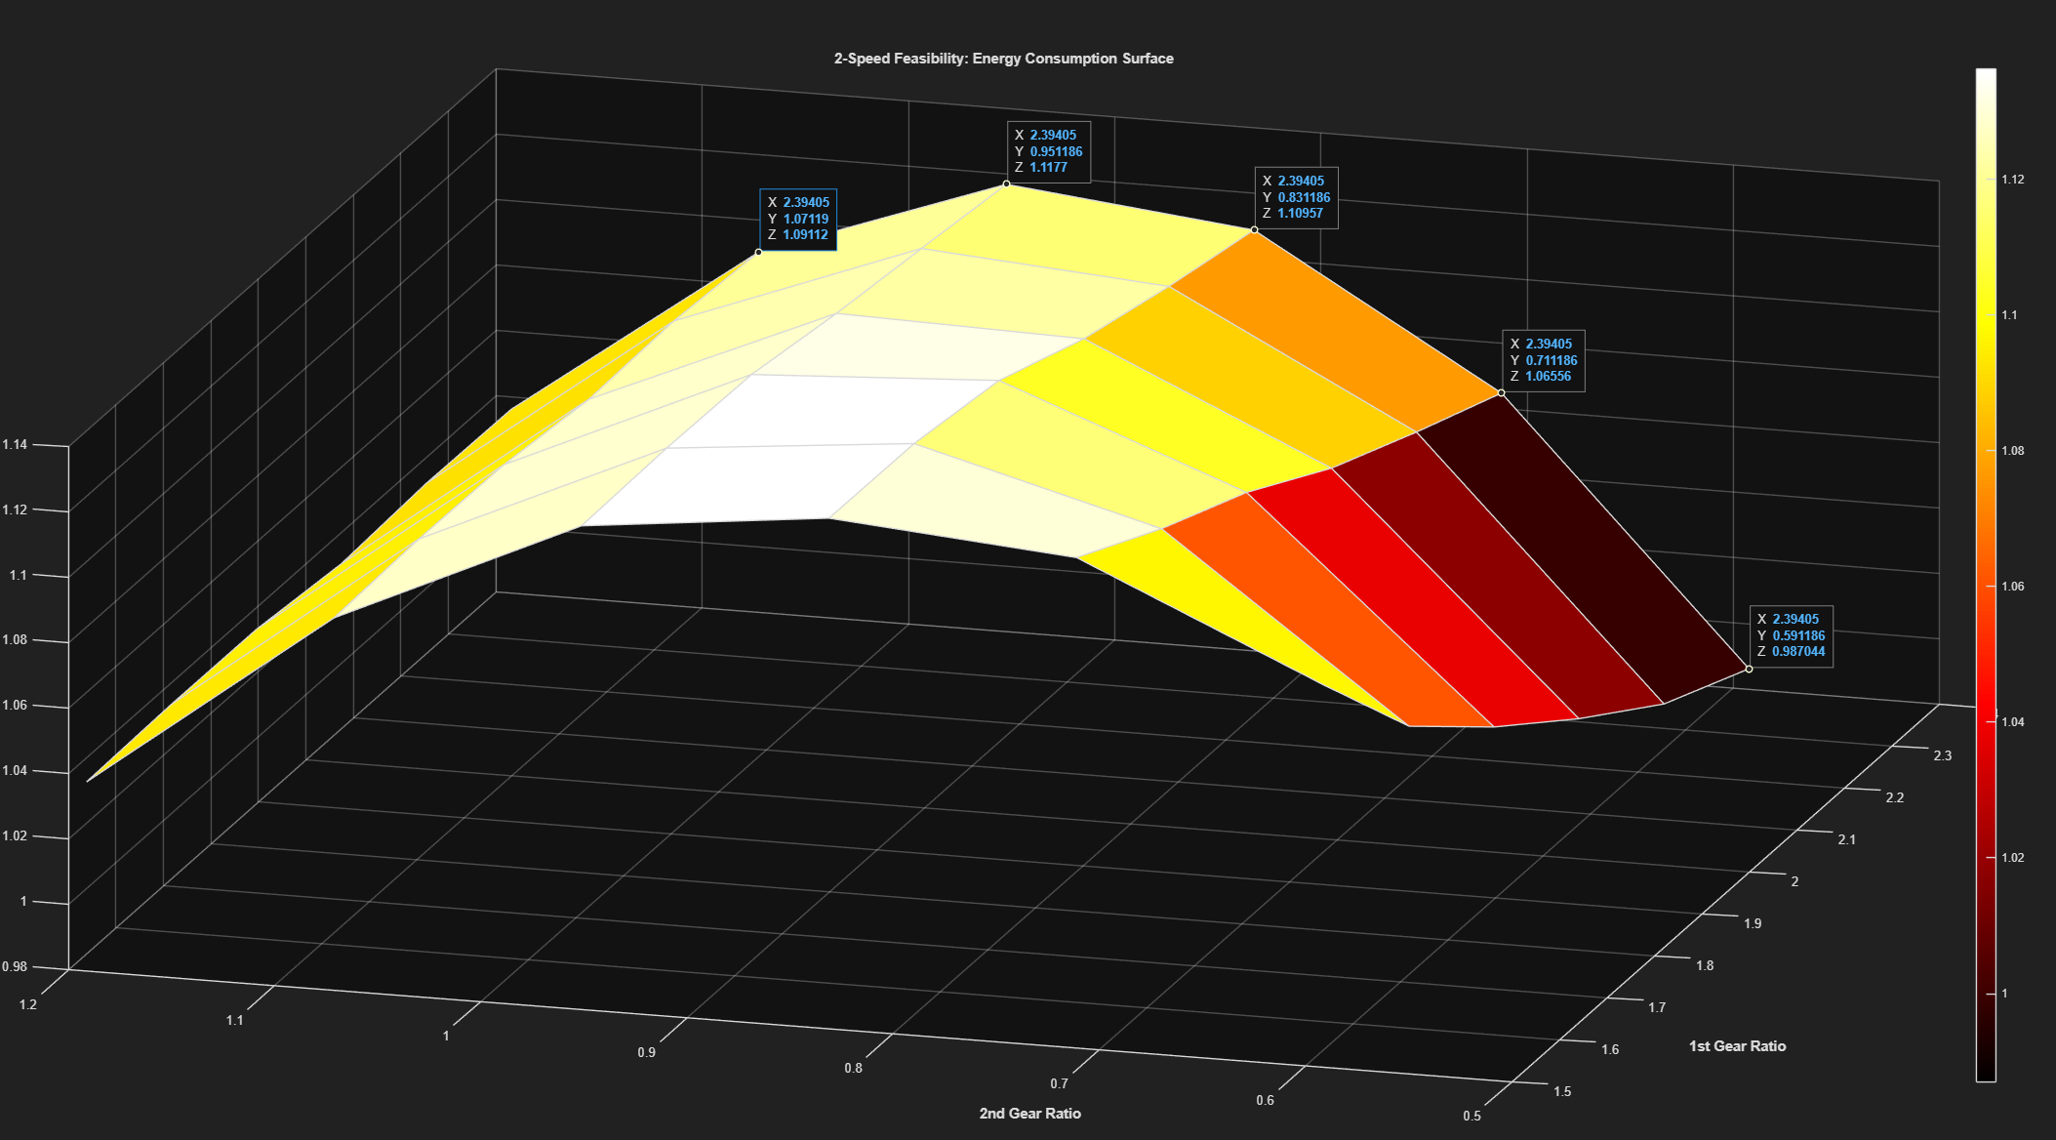
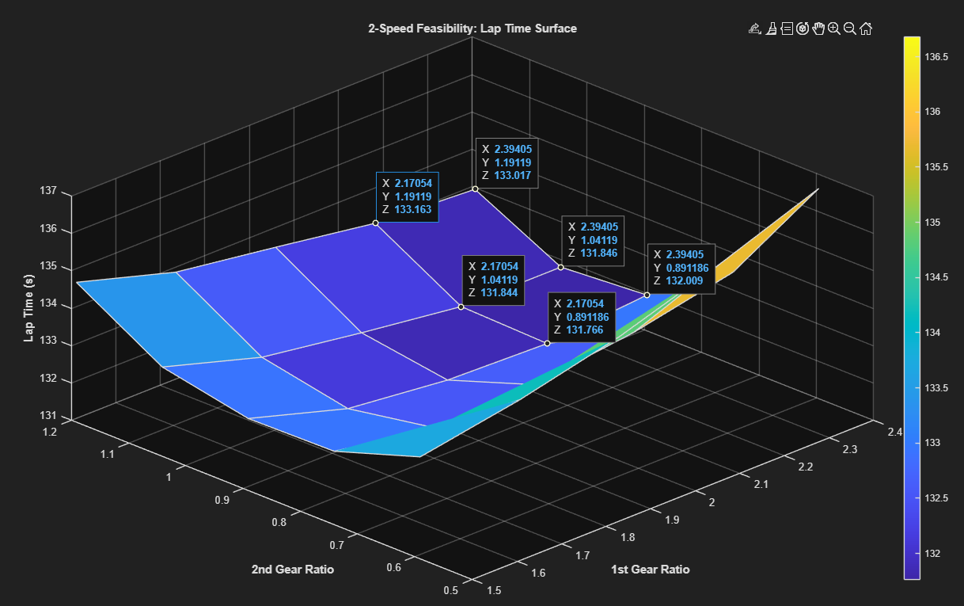
2 speed Gearbox laptime
2 speed gearbox energy consump
--- OPTIMAL 2-SPEED GEARS FOUND ---
1st Gear: 1.894
2nd Gear: 0.891
--- EVAL ---
Lap time: 131.820 s
Average vehicle speed: 38.52 m/s (138.68 km/h)
Top Speed achieved: 259.23 km/h
Energy Consumed: 1136.56 Wh (1.1366 kWh)
Energy Economy: 220.78 Wh/km
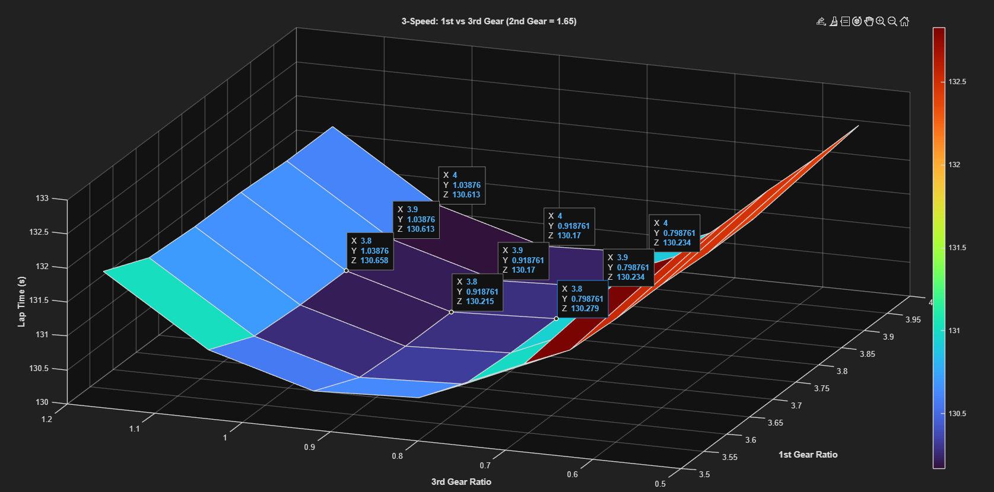
Optimised -> Lap: 131.82s | Top Speed: 259.2 km/h
--- OPTIMAL 3-SPEED GEARS FOUND ---
1st Gear: 4.000 <- (reached upper bound)
2nd Gear: 1.652
3rd Gear: 0.859
--- EVAL ---
Lap time: 130.167 s
Average vehicle speed: 39.01 m/s (140.44 km/h)
Top Speed achieved: 259.28 km/h
Energy Consumed: 1138.99 Wh (1.1390 kWh)
Energy Economy: 221.25 Wh/km
Optimised -> Lap: 130.17s | Energy: 1.14 kWh | Top Speed: 259.3 km/h
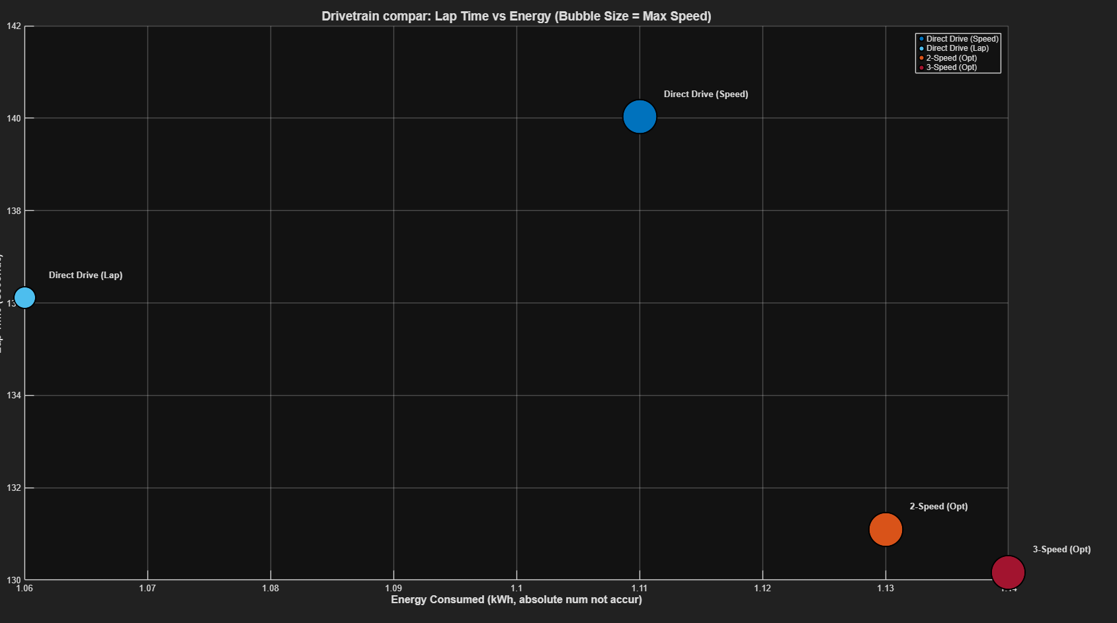
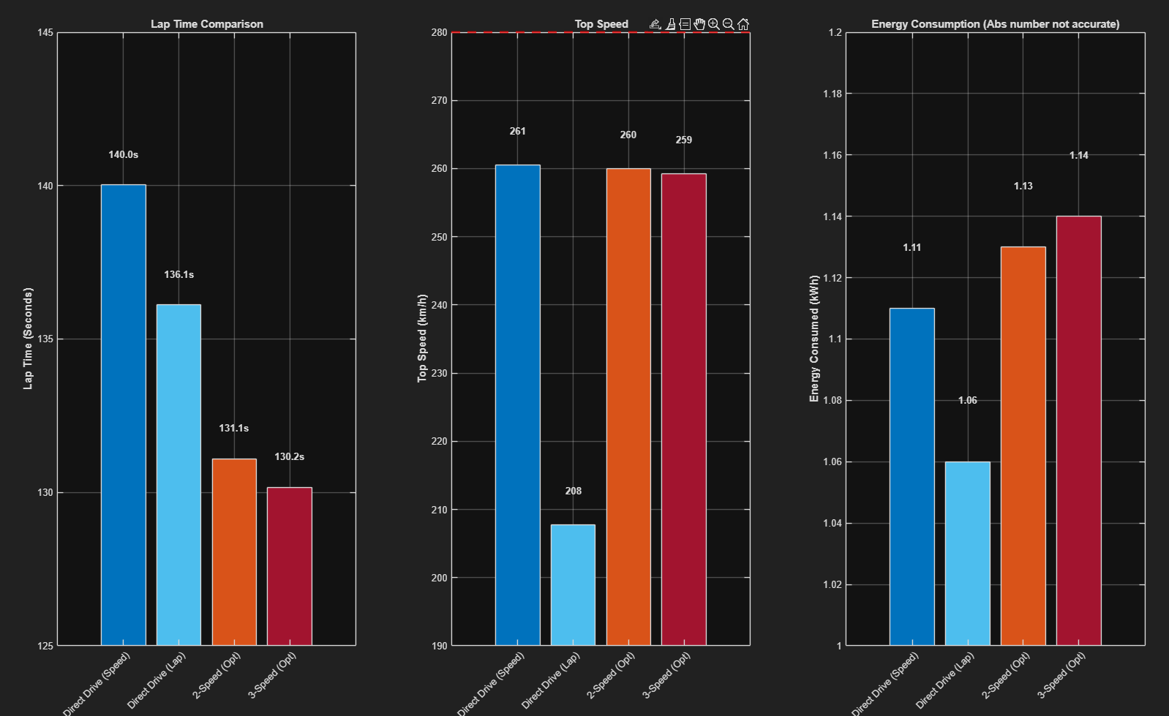
Assumptions made which improve attractiveness of 2&3 speed and would be worse IRL:
Gear shifting only causes a 50ms window of 0 acceleration whereas it would be much worse
There is no difference in mass between all the different drivetrains (2 and 3 speed would be much heavier than direct drive)

